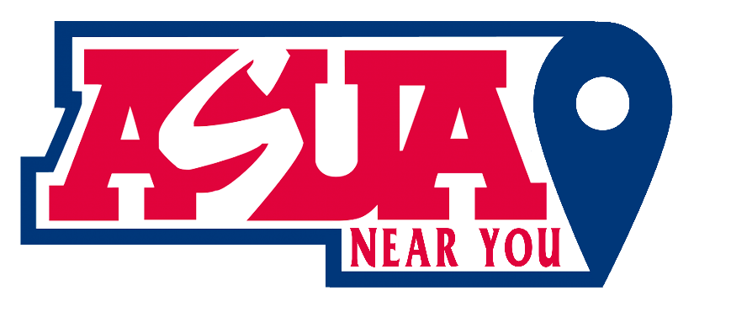

Meeting Agenda 12/1/2023

Date: 12/1/2023
Time: 2:00 PM - 3:00 PM MST
Zoom Meeting ID: https://arizona.zoom.us/j/86405373442?from=addon

Roll Call:
Lori Bentley Law – President
Madissen Miller – EVP
Owi Akpan - AVP
Annie Custer
Heidi Hopkins

Approval Of Minutes:
Minutes from 11/17/23.

Meeting Agenda:
Past Business:
- Updates on video project
- Update on YouTube
- Follow up with ASUA
- Goal Setting

New Business:
- LORI:
  - XX
- MADISSEN:
  - Update on Douglas & Nogales student donation fund
  - Update on Instagram budget purchase

- OWI:
  - Address Non-Functional Links on Association's Platform ‘Facebook’; discuss and resolve the issue of the broken link on our Facebook page, which currently leads to a 'Page Not Found' error, hindering access to vital association information.

- ANNIE
  - Interns are hosting a Game night on Tuesday, December 5th from 6-8 PM MST if you want to join! Might be a good place to build rapport with students.
  - Let’s check in on the Instagram ad insights/analytics.
    - Madissen—update budget spreadsheet with Instagram purchase
  - Don’t be alarmed if you get an email from UPCEA. We submitted your names for a mentorship program where you can be matched with a working professional in your field. No obligation to follow through with it, take it or leave it. Learn more here: https://upcea.edu/uplift-mentorship/
Announcements:
Adjournment:

N/A

