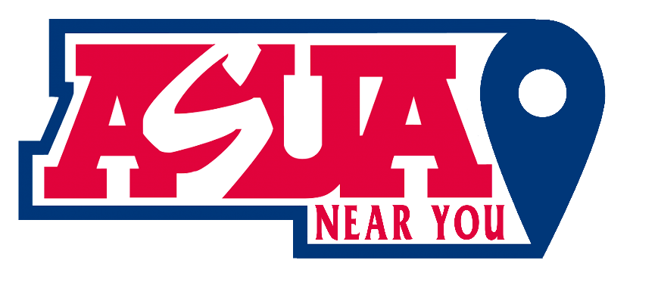

Meeting Agenda 12/15/2023

Date: 12/15/2023
Time: 2:00 PM - 3:00 PM MST
Zoom Meeting ID: https://arizona.zoom.us/j/86405373442?from=addon

Roll Call:
Lori Bentley Law – President
Madissen Miller – EVP
Owi Akpan - AVP
Annie Custer
Heidi Hopkins

Approval Of Minutes:
Minutes from 12/1/23.

Meeting Agenda:
Past Business:
- Follow up on ASUA/Caleb and Carole
- Two examples of connecting on Facebook
- Next Highlights in Line
- Feature Adam Taylor Young, who emailed us?

New Business:
- LORI:
  - Social Media Posting standards
  - UPCEA Meeting
  - Recognition of online achievements
  - Idea for maximizing orientation guest speaker
- MADISSEN:
  - Summary of Donation Fund meeting with Ada and Victoria
  - Update on boosted Instagram post
  - Guest speaker ideas for Spring semester (Budget use idea)
- OWI:
  - Lets talk Politics.

- ANNIE
  - I will reach out to everyone on January 8th/9th to find time for our one-on-ones and bi-weekly board meetings. Board meeting on January 12th?
  - Attempting to get y’all the ASUA-Main Campus constitution.
  - Here is some data on Instagram hashtags, where you can see the most popular ones that could help with exposure/reach.
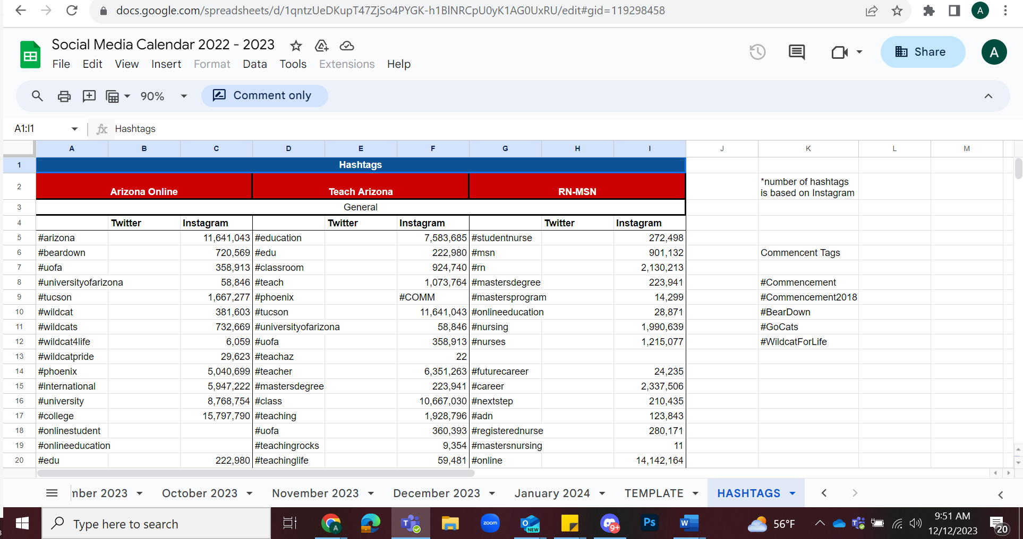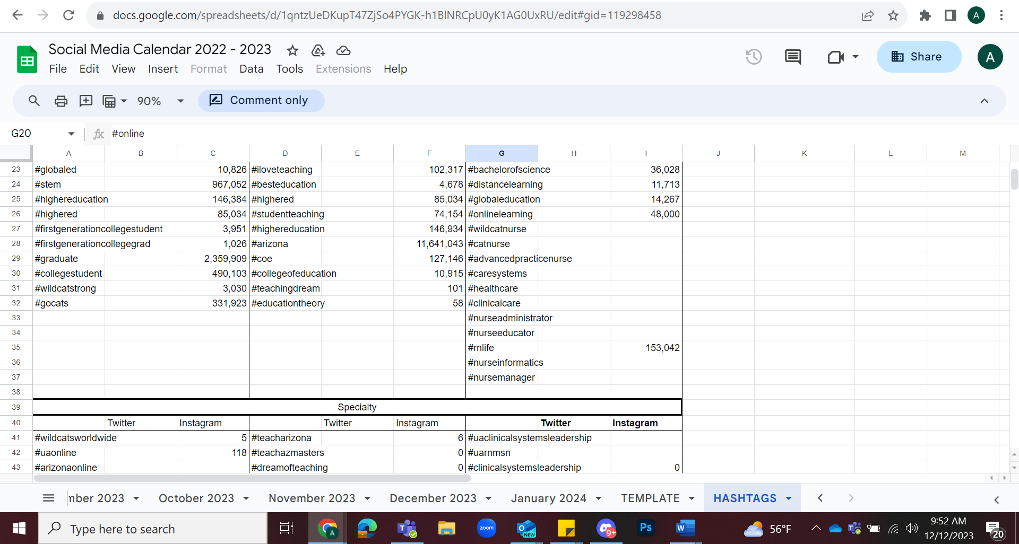
  - Options for January Retreat:
    - Virtual Vision Boards – Law of attraction; goal setting for the semester; set expectations
    - Social Media Workshop – Refine your voice on socials; reflect on past posts
    - Guest speaker
    - Belongingness Activity – Explore the impact you have in your role and best ways to include your constituents.
    - Paid SECD Presentation -
      - Wildcat 5: This presentation will explore five ways students can get started to help them be career-ready: creating online profiles such as Handshake & LinkedIn, developing a professional resume, growing a personal network, practicing interviewing skills, and seeking help to explore options. (45 minutes)
        - I would ask if they could cater this to leveraging your ASUA-NY position in your future careers.
      - Networking: This presentation focuses on how to leverage your network to discover potential internship and career opportunities. This includes using LinkedIn as well as other ideas for making connections. Methods of effective networking, professional etiquette, and strategies for fostering connections will be discussed. (45 minutes)
      - CliftonStrengths Assessment Workshop: CliftonStrengths is a tool that helps people understand their unique talents and how they are using them in their personal and professional lives. Our facilitators can guide your team through individual reflections and interactive activities to help them understand how to best contribute to the team, how to appreciate others’ strengths, and how everyone’s strengths interact to create a unique team profile. Participants will depart with a better understanding of both their personal strengths and their team strengths, as well as action items for continued development.

- HEIDI
  - Announcements
Announcements:
Recap Action Items:
Adjournment:

N/A

