Meeting Agenda 01/19/2024

Date: 01/19/2024
Time: 2:00 PM - 3:00 PM MST
Zoom Meeting ID: https://arizona.zoom.us/j/86405373442?from=addon

Roll Call:
Lori Bentley Law – President
Madissen Miller – EVP
Owi Akpan - AVP
Annie Custer
Heidi Hopkins

Approval Of Minutes:
Minutes from 01/10/24.

Meeting Agenda:
Past Business:
- Evaluation of social media strategy
- Primary objective of this meeting is to plan our visibility campaign

New Business:
- LORI:
  - Brainstorm name for our weekly cadence/visibility of ASUA-NY - Virtual Vibes: Connecting Wildcats Weekly?
  - Lori’s Monday Posts... Fueling the Week: Brewed Motivation with your ASUA-NY President
  - Discussion about Elizabeth’s video, and the video initiative
  - Comment on graphics
- MADISSEN:
  - Roar and Explore Wednesdays

- OWI:
  - Student spotlight brief
  - Alumni gallery brief
  - Funfact daily and weekend trivia
  - Connecting wildcats - Finding balance with owi

- ANNIE
  - Stipends were processed today so you should see it reflected on your account within a few days.
  - Social media reminders:
    - Always update Content Calendar when you post in Facebook and Discord.
    - Let’s limit it to one post per day per person so the algorithm doesn’t think your content is spam.
    - Send me your content for Facebook and Discord before posting to ensure proper branding, grammer, spelling, etc.
    - Include asuany email when doing outreach so folks know your message is legit and have another option for communicating if they don’t prefer DMs.
  - Results from last semester’s social media survey. N=25
  - 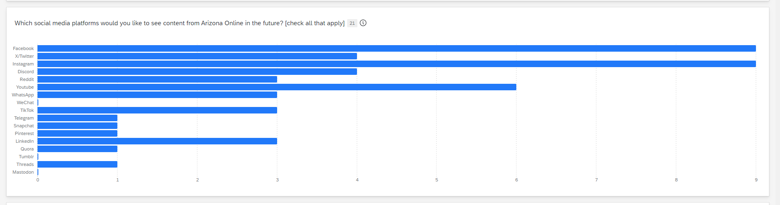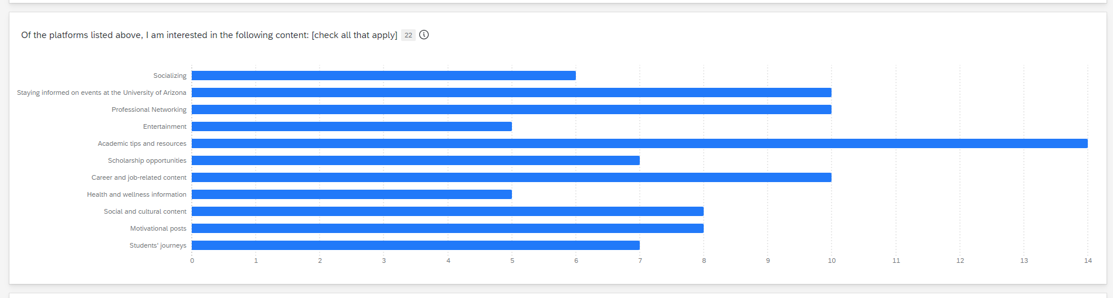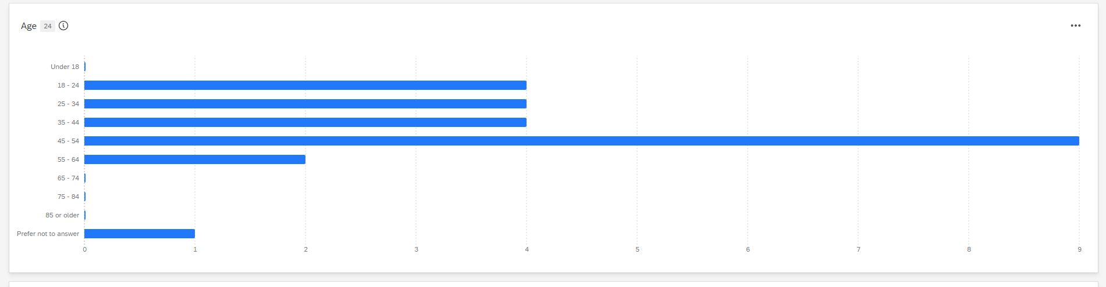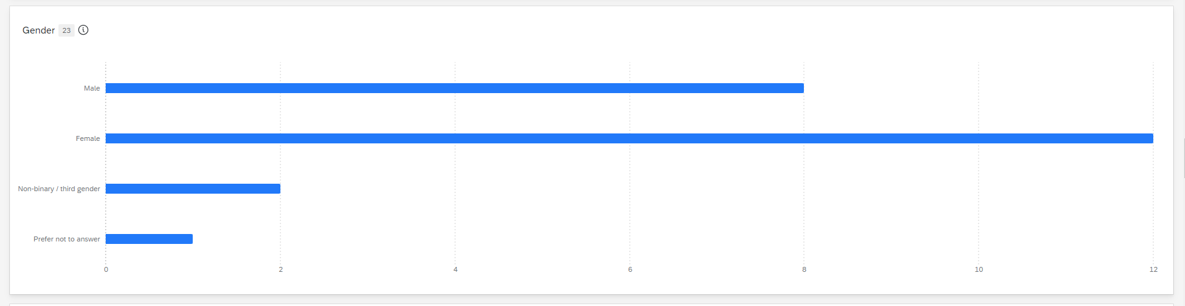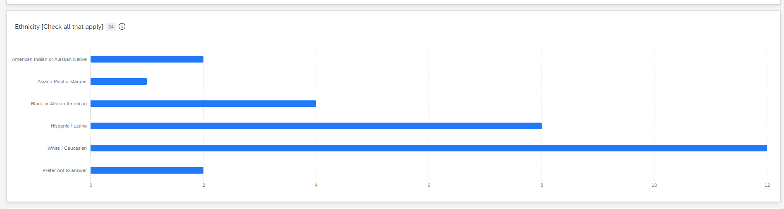
Announcements:
Adjournment:

N/A

