Meeting Agenda 02/02/2024

Date: 02/02/2024
Time: 2:00 PM - 3:00 PM MST
Zoom Meeting ID: https://arizona.zoom.us/j/86405373442?from=addon

Roll Call:
Lori Bentley Law – President
Madissen Miller – EVP
Owi Akpan - AVP
Annie Custer
Heidi Hopkins

Approval Of Minutes:
Minutes from 01/19/24.

Meeting Agenda:
Past Business:
- Evaluation of Virtual Vibes. What’s working? What isn’t?
- Follow up on Elizabeth Rivas video and talk about how to frame concerns
- Update on Dean’s List change

New Business:
- LORI:
  - Pres. Robbins email including ASUA and why we’re not included
  - Talk about succession plan and finding officers for next year
  - Rebranding/Restructure ASUA-NY
- MADISSEN:
  - Guest speaker invitations to Melody Buckner and Leslie Sult
  - Main campus library for a post

- OWI:
  - Adams VHL complaint
  - Online student flex
  - Student spotlight post to come

- ANNIE
  - Advertising for new board
    - Announcement
      - Email, social media, Launch Pad, Online Wildcat, ASUANY website.
      - We want resumes, interview dates, eligibility, cover letter with suggested prompts.
“ASUA-Near You is the branch of student government for Arizona Online and Near You Network undergraduate students. They work to enhance student life by being the voice between the students and University leadership, as well as expanding engagement and leadership opportunities for Arizona Online & NYN students. ASUA-NY is recruiting now for the 2023-24 Student Government! Student leaders earn a stipend, based on elected role. Current open positions include:
President
Executive Vice President
Administrative Vice President
Interested? Submit your applications HERE

Bear Down!

ASUA-NY Board Members”
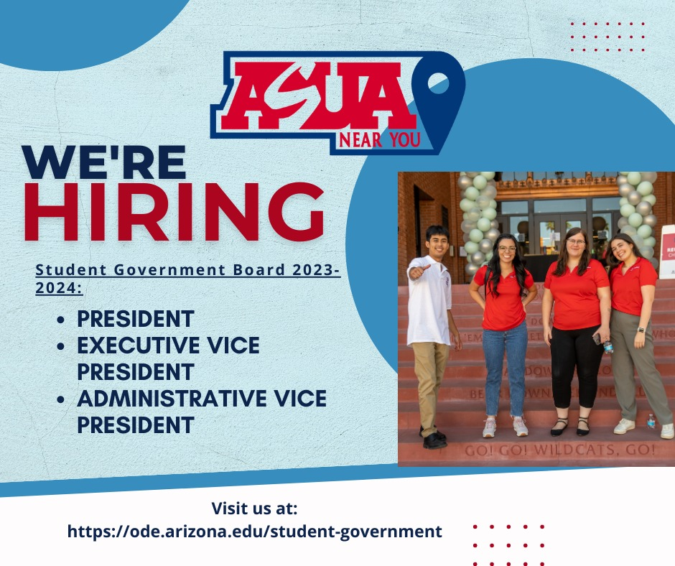
  - Continuity notes.
Announcements:
Adjournment:

N/A

